COMMUNICATION AND VISUALIZATION FOR DATA ANALYTICS  
  
  
ALY6070, WINTER 2020  
MODULE 6 PROJECT

SIGNATURE ASSIGNMENT

SUBMITTED BY: SIDDHARTH MANI, ANUPREETA MISHRA, SHIVANI ADSAR, PARINITA MAHINDRAKAR, SHRADDHA GOPALAKRISHNAN

NUID: 001410242, 001050752, 001399374, 001069853, 001376444

SUBMITTED TO: PROF. JACK BERGERSEN

DATE: 03/28/2020

**Introduction**

In this assignment, we have worked on the “Bike Sharing Dataset” for performing data analysis to find how different variables affect the profit. We also consider the changes in the environment and road conditions that affect the sharing [2]. This dataset gives information about the duration

of travel, departure and arrival position, which is explicitly recorded, corresponding to years 2011 and 2012 from Capital Bikeshare system, in Washington D.C. [1] We have performed explanatory analysis and Visualizations using Tableau software which helped in better analysis.

We concluded the project by answering 3 research questions:

1. How will you convert casual rides to registered rides?

2. How does the season and time affect the demand for bikes?

3. Why is there an increase of bike rentals over the two years?

**Analysis**

In the “Bike Sharing Dataset”, we have performed the below analysis to find the factors that affect bike rental count in Washington DC.

* To figure out which Type of users rent more, we use Fig 1.

1. It depicts whether the bike rentals are by casual or registered users and shows the count of the rides for the year 2011 and 2012.
2. We see that the count for 2011-2012 Casual Rides are 247,252 and 372,765 respectively. About the Registered Rides, the figures are 995.8K (2011) and 167.6K(2012).
3. It was observed that Registered Users were responsible for around 4 times as many trips as Casual over 2 years.

Figure : Casual vs Registered Bike Rentals

* To figure out which Year users rent more, we use Fig 2.

1. Fig 2. portrays total count of the bike rides for the highlighted months January, June, September and October with peak count of 218.5K in September.

2. It can be observed that in 2012 the numbers have increased by 64.8% than that in 2011 maybe because people started becoming health conscious and aware of the environment.

Figure : YoY Analysis of Bike Rentals

Figure : Casual vs Registered Hourly Trend

* To figure out hourly trend, we use Fig 3.

1. We analyze that the count for both is highest for the hour 5 PM due to nice natural light and good evening weather.

2. The observation here is that the registered users have higher count at 8AM and 5PM indicating peak hours for people commuting to work from home and vice-versa.

3. There is a gradual increase in count of casual riders from 7AM with highest peak at 2PM and then decreases.

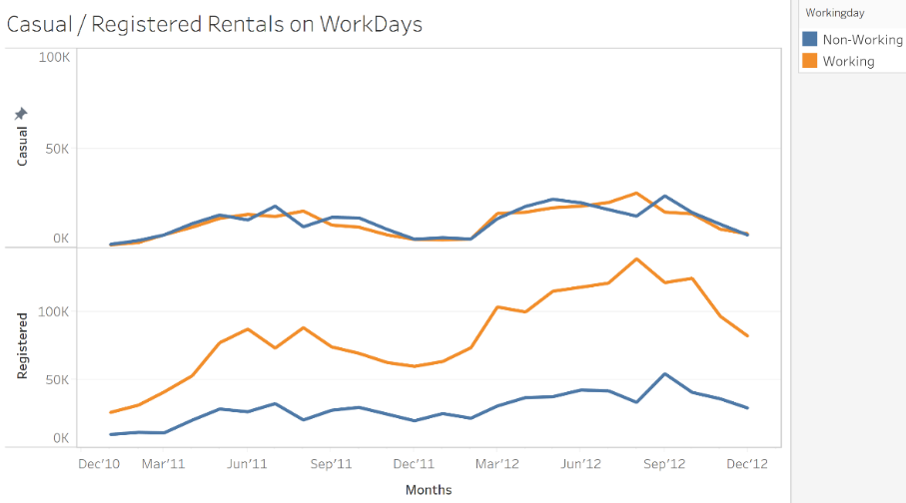

Figure :Casual vs Registered on Work Days

* To figure out week-day vs week-end trend, we use Fig 4.

1. Registered users follow a seasonal pattern for working and non-working days.
2. As observed, the count of bike rides for casual users for working and non-working days was similar.
3. The count of rides on working days for registered users is higher because of a fixed routine.

* 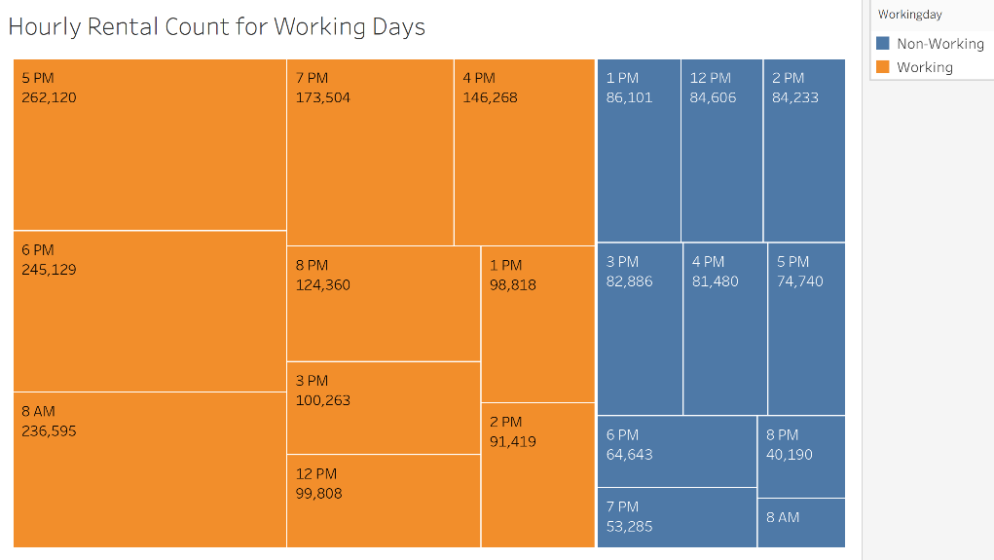To figure out hourly rental count for working days, we use Fig 5.

Figure :Hourly Rental Count for Working Days

1. Maximum rentals observed in working days.

2. Peak hours of working days show highest rental count of 262,120 at 5PM.

3. For non-working days, highest count of rentals is 12-4 PM for leisure.

* To figure out hourly rental count over season, we use Fig 6.

1. This chart shows bike rentals for the four seasons where the darkest color indicates the highest value.

2. As seen from the chart, Fall is the most appropriate weather for bike rentals followed by Summer, Winter and Spring.

3. Fall has the maximum count with 1.06M rides and Spring with 471.3K rides has the least count.

Figure : Seasonal Bike Rentals

* 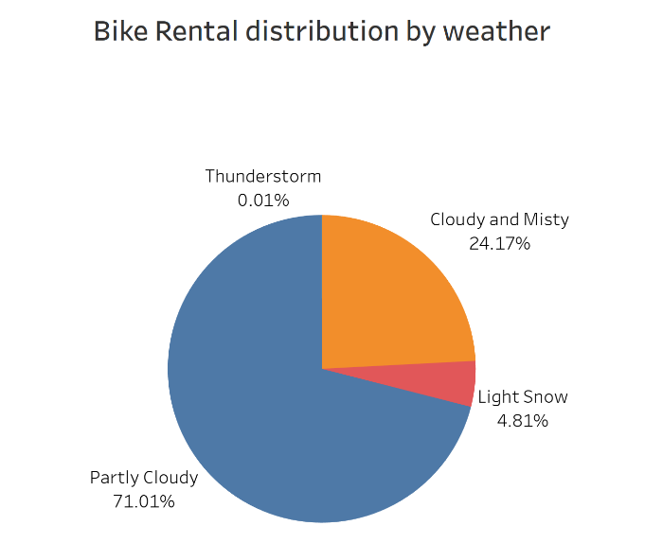To figure out the weather distribution, we use Fig 7.

1. When distributing rides based on weather, we get a beautiful Pie-chart depicting percentages of ride counts during different weather.
2. It can be noted that around 3/4th of bike rentals happen in Partly Cloudy weather followed by Cloudy and Misty weather.
3. The obvious reason for highest bike rentals on a Partly Cloudy weather is clear vision and track conditions.

Figure : Bike Rental distribution by weather

* 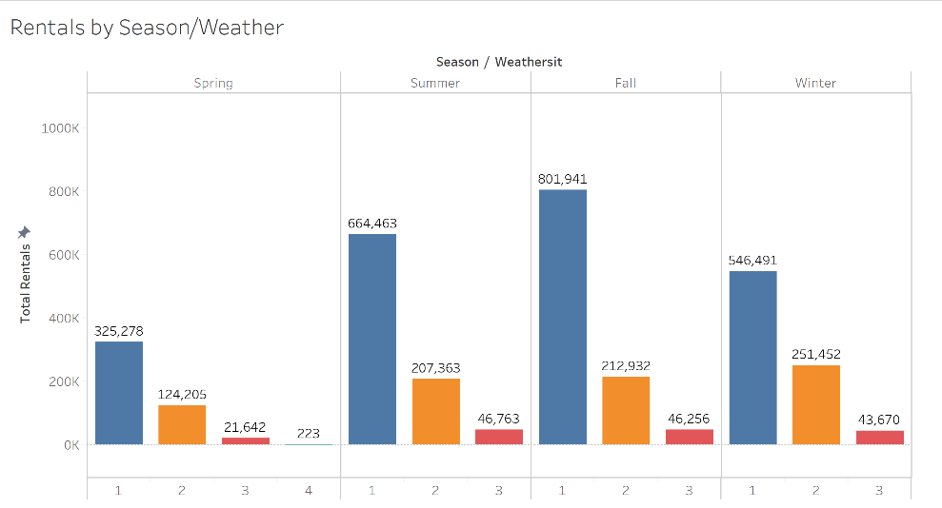To figure out rentals by weather, we use Fig 8.

1. Highest Rentals observed for Partly Clouded Weather followed by Mist + Cloudy and Light Snow.

2. Lowest Rental observed in Spring for Thunderstorm.

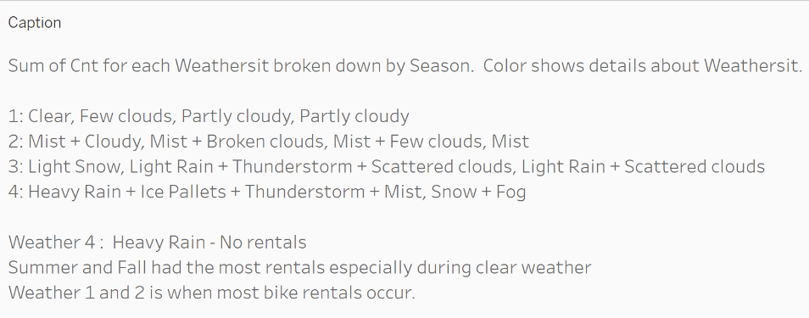3. Clear weather during Fall season had the maximum number of Bike Rentals.

Figure : Bike Rentals by weather

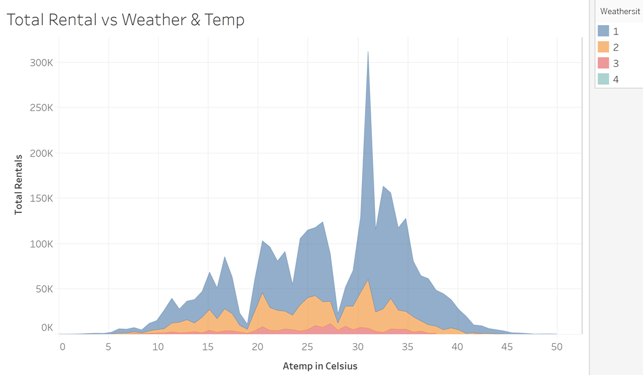

Figure : Total Rental vs Weather & Temperature

* To figure out total rental vs weather and temperature, we use Fig 9.

1. Clear weather of 30-32 degree Celsius was preferred for renting bikes.
2. We can see that the bike rentals were on the lower end for extreme temperatures while 20-35 degree Celsius was preferred across different weather conditions.
3. The trough noticed at 19 and 28 degree Celsius is due to high windspeed and high humidity respectively, as seen in the next graph.

Figure : Rental vs Weather Paramters

Figure : Bike Rental vs Weather Parameters

* To figure out rental vs weather, we use Fig 10.

1. We here see the average rentals was dependent on the average temperature (Feeling temperature) and windspeed.
2. Higher temperatures and lower windspeed favored more rentals.
3. There seems to be no association between Humidity and Rentals.

**Dashboards created for storytelling in Tableau.**

**1.** User Analysis based on working/non-working days.

**2.**  Bike Rental Analysis based on Weather and Temperature.

**Conclusion**

As per our research questions we came with the following solutions-

**To convert casual rides to registered rides:**

1. Promotions and making contract with companies for commuting purpose of employees will increase the count of registered users for working days.

2. Providing offers for registered users during holidays.

**Effect of season and time on the demand for bike rentals:**

1. People seem to ride bikes more during Fall as the temperature ranges between 30 and 32 degree Celsius.

2. Moreover, Fall attracts more tourists hence increasing the bike rentals.

3. Clear and Partly Cloudy weather provides a pleasant and safe environment for riding bikes.

**Increase of bike rentals over the two years:**

1. People have become more environment, health and money conscious.

2. Since it is a safer option, people started preferring bike rentals.

3. Bike Rentals are a cheaper alternative for students as compared to other transportation services.

**References**

1. Motivate International, Inc. (n.d.). System Data. Retrieved from <http://capitalbikeshare.com/system-data>
2. Analytic Methods in Research. (n.d.). Retrieved from <https://www.scopus.com/record/display.uri?eid=2-s2.0-85032566625&origin=inward&txGid=4e9a8dbe3510419b44349908631202af>
3. Tableau - Dashboard. (n.d.). Retrieved from <https://www.tutorialspoint.com/tableau/tableau_dashboard.htm>